Java Interview Questions

1. Is Java Platform Independent if then how?
Yes, Java is a Platform Independent language. Unlike many programming languages javac compiler compiles the program to form a bytecode or .class file. This file is independent of the software or hardware running but needs a JVM(Java Virtual Machine) file preinstalled in the operating system for further execution of the bytecode.
Although JVM is platform dependent, the bytecode can be created on any System and can be executed in any other system despite hardware or software being used which makes Java platform independent.

2.How is Java platform independent?

Step-by-Step Execution of Java Program

- Whenever a program is written in JAVA, the javac compiles it.
- The result of the JAVA compiler is the .class file or the bytecode and not the machine’s native code (unlike the C compiler).
- The bytecode generated is a non-executable code and needs an interpreter to execute on a machine. This interpreter is the JVM and thus the Bytecode is executed by the JVM.
- And finally, the program runs to give the desired output.

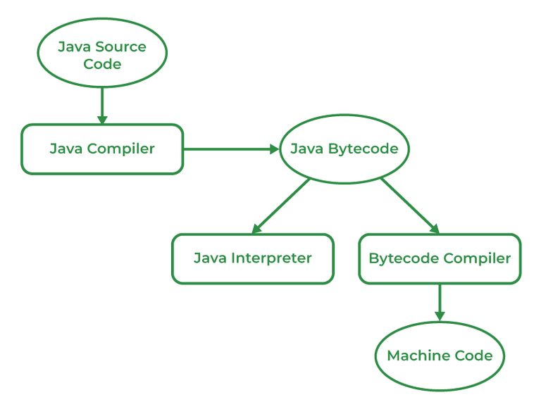

3. Why Java is platform-independent but JVM is platform dependent?
- In Java, the main point here is that the JVM depends on the operating system – so if you are running Mac OS X you will have a different JVM than if you are running Windows or some other operating system.

- This fact can be verified by trying to download the JVM for your particular machine – when trying to download it, you will be given a list of JVMs corresponding to different operating systems, and you will obviously pick whichever JVM is targeted for the operating system that you are running. So we can conclude that JVM is platform-dependent and it is the reason why Java is able to become “Platform Independent”.

